MAGYARORSZÁGI VADÁSZLÖVÉSZEK EGYLETE
SPORTING CLAYS FEDERATION HUNGARY

39th. Fitasc World Sporting Championship 2017
July 6th.-9th. at the Pilis Park Forestry, H-2183 Galgamácsa / Hungary

INVITATION

Dear friend,

You are cordially invited to participate in the above mentioned event, organized by the Pilisi Parkerdő Zrt. (Pilis Park Forestry) together with MVE / Magyarországi Vadászlövészek Egylete (Sporting Clays Federation Hungary) at the Galgamácsa Shooting Ground, H-2183 Galgamácsa, Kastélykert 1 GPS: 47,72 52 744 N
19, 41 79 296 E

Name :
Nationality :
Passport number :
Valid until :
National Gun Licence number : Shotgun brand, and model : Serial number :
Caliber/ Gauge :
Amount of ammunition (if any ) :

Entry / Registration: Info as usual, on the World Federation's website: www.fitasc.com I hope to see you in Hungary next July!
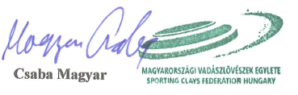

Csaba Magyar

President of MVE / Sporting Clays Federation Hungary

Magyarországi Vadászlövészek Egylete Sporting Clays Federation Hungary
H-8131 Enying, M ikszathKalman utca 3/a Phone: +36 30 937 5067
E-mail: csaba@magyarestarsa2000.hu Website: www.fitascsporting.hu

